Anthony Redamonti

Syracuse university

Homework 3

CIS-623 structured programming & formal methods

prof. Mehmet kaya

1/27/2022

Question 1:

Are the following formulas valid, satisfiable, or unsatisfiable?

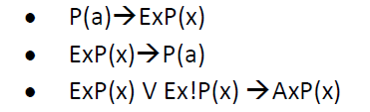

P(a) -> ExP(x) is valid based on the inductive Ex rule.

ExP(x) -> P(a) is satisfiable.

ExP(x) V Ex!P(x) -> AxP(x). The right side of the disjunction is always false. The left side is satisfiable. Therefore, the formula is satisfiable.

Question 2:

For each of the following sequences, give a formal proof if entailment holds.

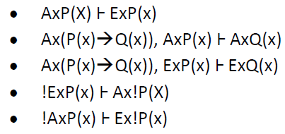

1. See proof in picture below.

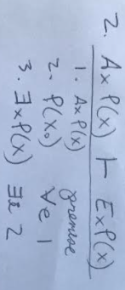

1. See proof in picture below.

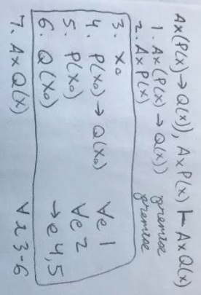

1. See proof in picture below.

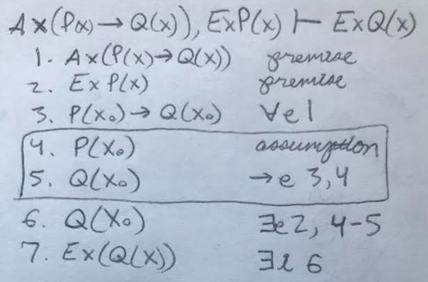

1. See proof in picture below.

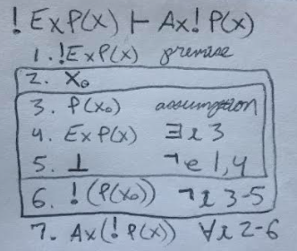

1. See proof in picture below.

